**Steps to deploy the Databricks Cluster inside the existing Vnet:**

1. Create a Vnet in any region you want and create public subnet and private subnet as shown below:

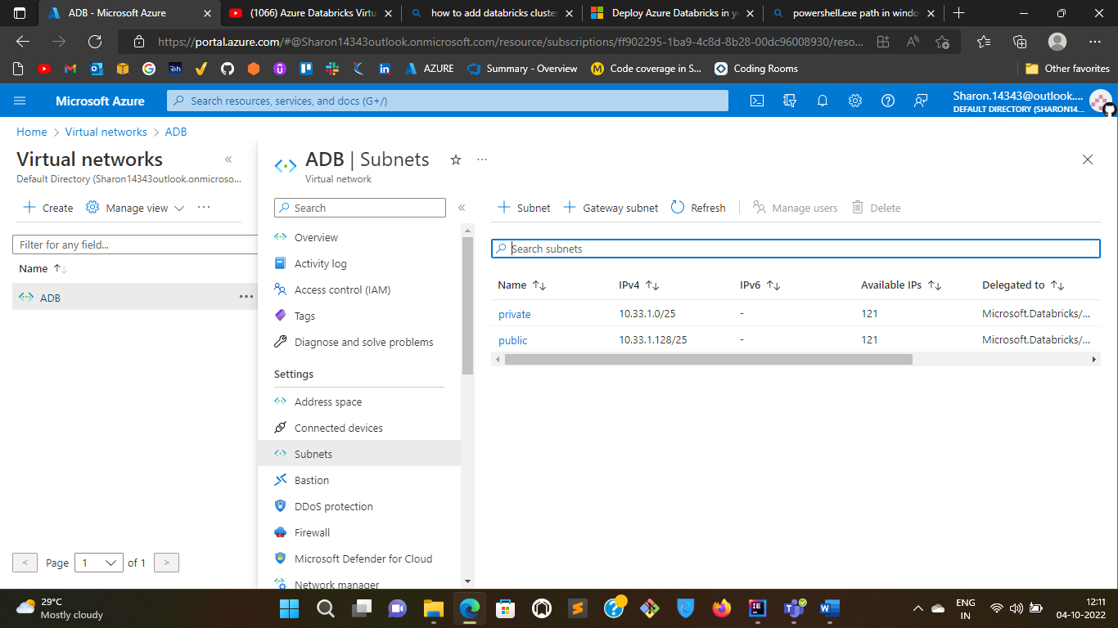

1. Search for Azure Databricks inside Azure Portal and create a workspace as below:

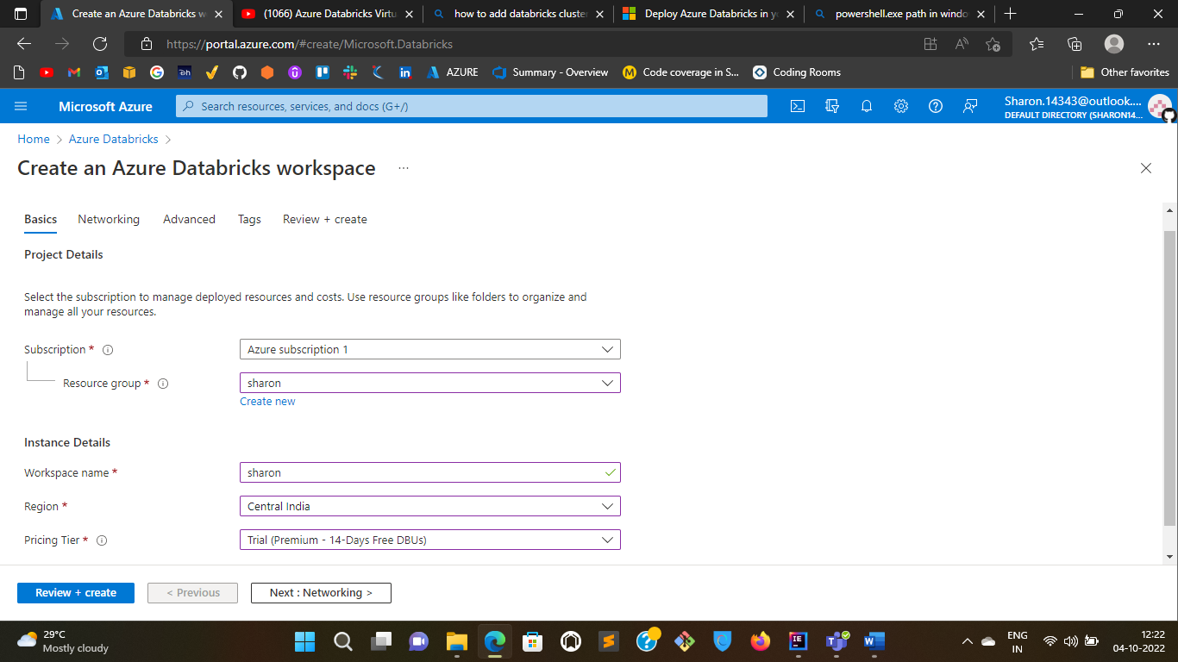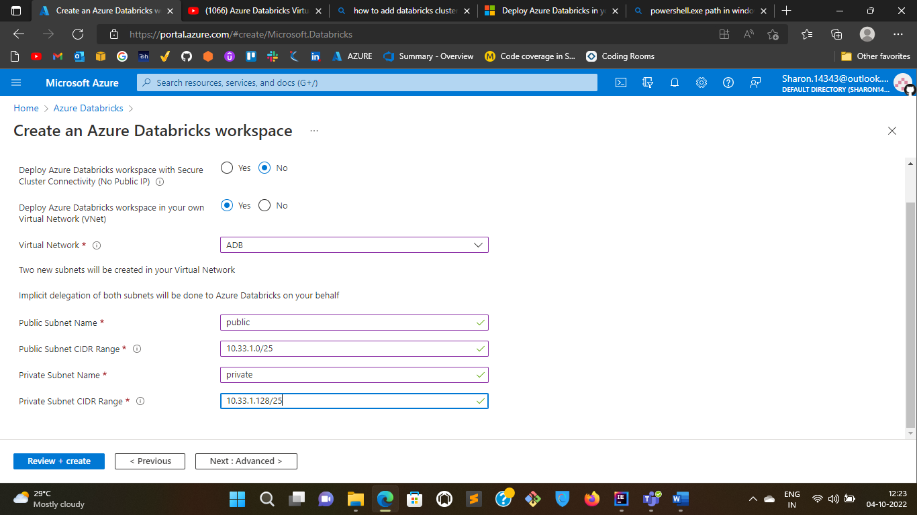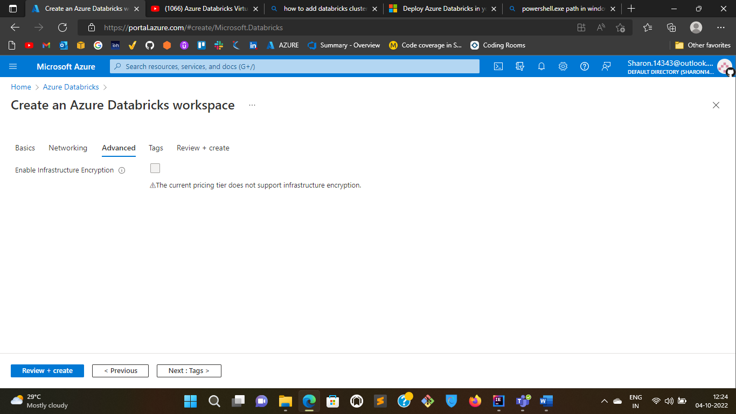

1. Now create a cruster in the workspace and the cluster will be created in the existing vnet.

